Partial exam
- algorithms -

Exercise 1
10 min

1p a) Remember that Dijkstra algorithm? You were given a graph with some weight on the edges and you had to find the minimum spanning tree. This algorithm is quite famous; it is also solved by a notorious algorithm design strategy. Can you name that strategy? Also describe it in a few words (3 lines max).

2p b) An algorithm which tries to solve the 3-queen problem prints the following logs to the console:
1 | 0 _ _ | Partial solution | ➔
2 | 0 0 _ | fail
3 | 0 1 _ | fail
4 | 0 2 _ | Partial solution | ➔
5 | 0 2 0 | fail
6 | 0 2 1 | fail
7 | 0 2 2 | fail | 🡸 🡸
8 | 1 _ _ | Partial solution | ➔
9
10
11
12
13
14
15
16
17
18
19

Complete rows 9 to 19 and find all the solutions if there are any. Only write the missing info.

Exercise 2
7 min

2p a) Read the whole problem before starting working on it. Given an array of N integers, re-arrange integers in the array such that the global sum listed below is maximum.
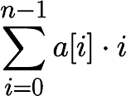
The following code snippet attempts to solve the problem stated above.
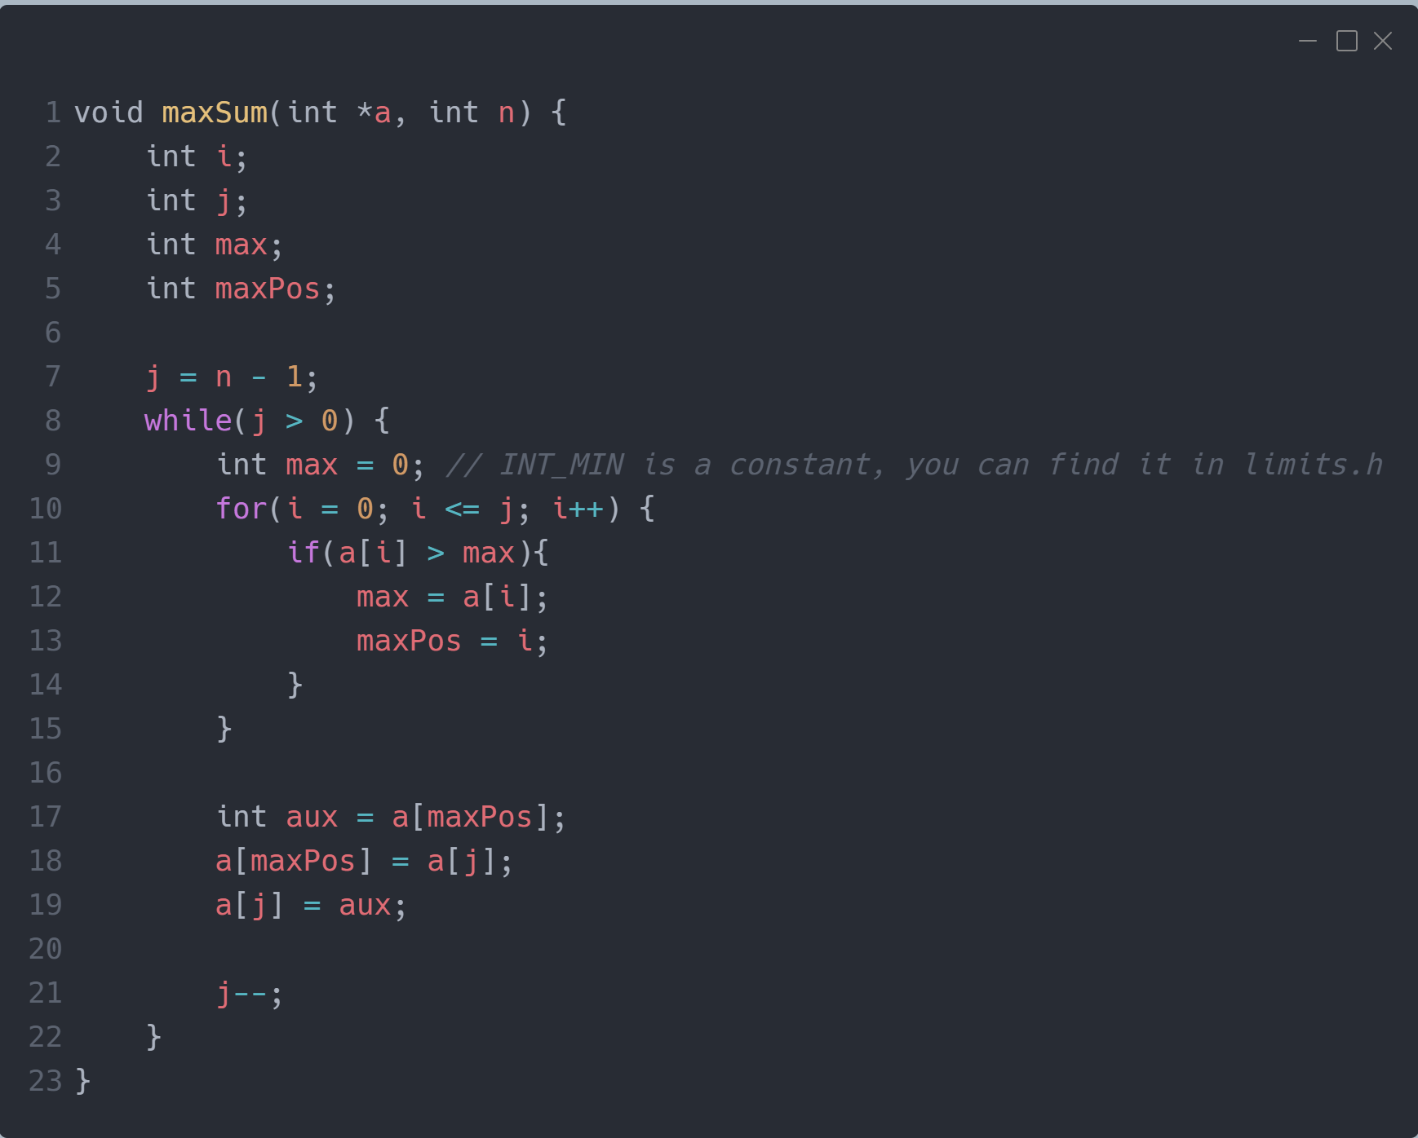
You have to read the algorithm and describe the strategy used to implement it. Don’t describe the code. Describe the strategy and its motivation as briefly as possible.

1p b) What is memoization and how does it help?

Exercise 3
30 min, 3p

For this exercise you will have to write C code in CodeBlocks. Instead of uploading a photo, upload the “main.c” file.

Given a N by M matrix, count how many possible paths are there from the bottom left corner, (0, 0) to (N – 1, M – 1) with the constraint that you can only go north, east and northeast.

Example:
Nr. Crt. | Input | Output | Image
1 | N = 1  M = 1 | 1 | -
2 | N = 2  M = 2 | 3 | 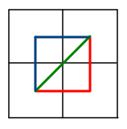
3 | N = 2  M = 3 | 5 | 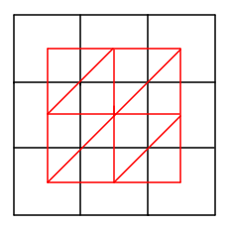

A solution which does not compile is worth 0p.
A solution using Divide et Impera is worth 1.5p.

Partial 2 rules:
- There is a good chance you won’t have time to solve all the exercises. Solve as many as you can in the given time slot. You can get a high grade without solving everything.
- Write on the sheet of paper only what is required. Do not copy the code written in the document containing the exercise description.
- Write your name on all the papers used to solve the exercises.
- This exam is open-book. You can use any resource. Collaboration is strictly prohibited. Discord, Skype, Google Meet or any other kind of service that enables collaboration during the exam is forbidden.
- Exams that have weird/similar/outrageous answers will be canceled and the student will have to retake the exam.
- For each exercise you will have a certain time slot allocated + 1 m 30 s to photograph and upload the picture on Github.
- Make sure you are on the “partial2” branch. After pasting an image named “exercise_#.png/jpg” in the “partial2” folder, use git add . , git commit -m “exercise #” and git push.
- If you encounter git problems during the exam you are the one responsible for solving them. We’ve been using Git for a FULL semester now, not knowing these basics will make you eligible for failing the partial exam.
- You will have to add, commit, and push after each exercise.
- Commits submitted after the time slot has ended will not be graded.
- I will share with you a PDF file containing exercise N after starting the timer. I will announce when the time slot has ended and I will start the timer for 2 extra minutes for you to upload the photographs. We will take a short break after which we continue with exercise N+1.

There are 3 exercises. Here’s the weight of each exercise:
10 min 1. a) 1 p b) 2 p
7 min 2. a) 2 p b) 1 p
30 min 3. a) 3 p

Total work-time: 47 min
Total points: 10 p, 1 p from THE OFFICE

You need at least 5 p to pass this exam.

